The Sukhothai Bangkok has been named the #1 City Hotel in Bangkok
in the Travel + Leisure 2020 World’s Best Awards

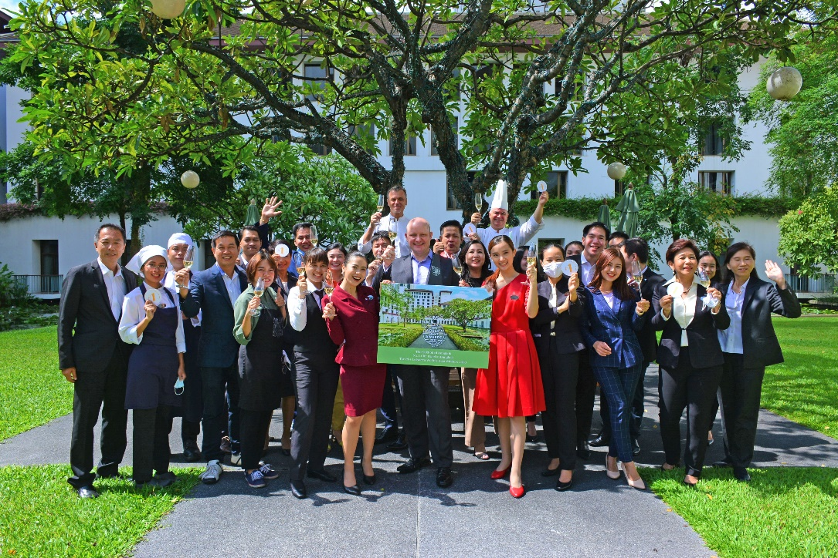

The Sukhothai Bangkok has achieved the most prestigious awards in the annual “Travel + Leisure 2020 World’s Best Awards”, which is celebrating its 25th anniversary of the World’s Best Awards this year.

#1 City Hotel in Bangkok
#4 Hotel among all Asian Cities
#37 Hotel Worldwide

Travel + Leisure magazine, a compendium of the highest-ranking hotels and resorts worldwide as voted by readers in the Travel + Leisure World’s Best Awards survey.

The full list for 2020 World’s Best Awards: https://www.travelandleisure.com/worlds-best/worlds-best

The Sukhothai Bangkok, a resort-style sanctuary, is set amid six acres of lush greenery and lotus ponds in the heart of Bangkok, with the combination of traditional Thai refinement, immaculate contemporary style and personalized service.

As of 1 August 2020, The Sukhothai Bangkok will resume our service of delighting guests with a unique Thai experience.

About The Sukhothai Bangkok
The Sukhothai Bangkok combines traditional refinement with immaculate contemporary style. A haven of calm set amid six acres of lush gardens and water ponds in bustling Bangkok. Once inside its classically elegant grounds, guests are quite literally far from the madding crowds. Wining and dining is a pleasure with world class Restaurants and Bars, including the award-winning La Scala Italian Restaurant, Celadon, home of delicious Thai cuisine and Colonnade an international cuisine Restaurant. On-site leisure facilities include Spa Botanica, a Fitness Studio with fully-equipped Gym, Sauna and Jacuzzi and a 25-metre outdoor Swimming Pool.

*********

For further information, please contact:
Chutima Limpasurat – Director of Marketing Communications
Tel: +66 (0) 2 344 8671 or email to chutima.l@sukhothai.com
Thank you for your continued support to The Sukhothai Bangkok
https://www.sukhothai.com/bangkok/en

